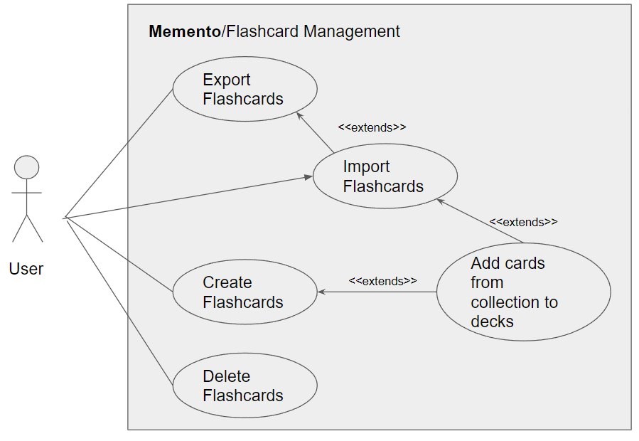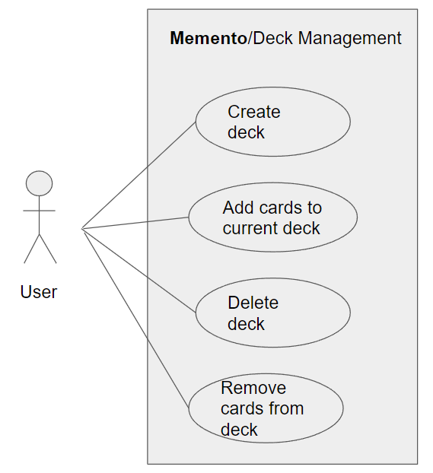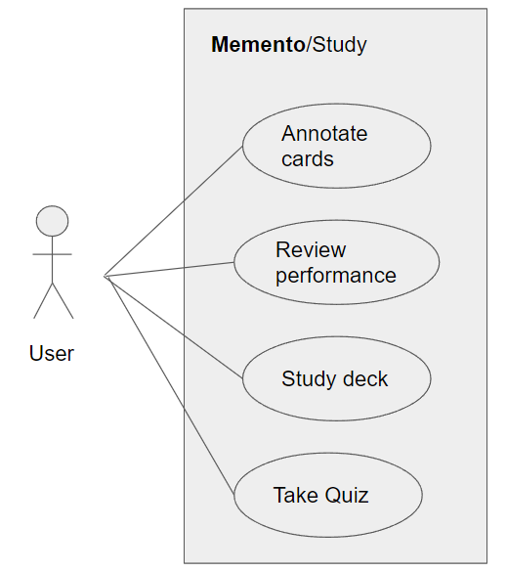

| Name/Title: | Create Flashcards |
| --- | --- |
| **ID:** | 0 |
| **Description**: | Allows the user to provide notes which will be parsed using one of a set of possible delimiters. The parsed text will be processed to provide a resulting set of flashcards which are added to the user’s collection. |
| **System Under Design:** | Memento |
| **Primary Actor**: | User |
| **Participants**: | None |
| **Goal**: | Allows a user to convert notes into flashcards, while building their collection of available flashcards. |
| **Related Use Cases**: | Instance of: None  Included by: None  Inclusions: None Extensions: <3, Add cards to deck> |
| **Invariant**: | The text provided by the user must not result in errors which the app fails to account for (e.g. through input sanitization). |
| **Precondition**: | User accesses main menu of the app |
| **Success Postcondition**: | Flashcards are added to collection |

| **USER STEPS**:  1. User enters main menu of Memento, either by opening the app or clicking on the “Memento” logo along the top menu bar in the apps UI.  2. User enters notes as plain text in the entry form.  3. User selects “Add”  5. User makes the selection and submits “Continue” | **SYSTEM RESPONSE**:  4. Memento asks the user to select which delimiter(s) should be used from a menu.  6. The text is parsed with the selected delimiters to output a set of flashcards.  7. Flashcards are added to the user’s collection |
| --- | --- |

| Name/Title: | Add Cards from collection to decks |
| --- | --- |
| **ID:** | 1 |
| **Description**: | Allows the user to add cards from their collection to specific decks. This can be done at the time of card creation or by selecting a card in the collection |
| **System Under Design:** | Memento |
| **Primary Actor**: | User |
| **Participants**: | None |
| **Goal**: | Allows a user to organize their cards into a set of decks so that they can study specific subjects. |
| **Related Use Cases**: | Instance of: None  Included by: None  Inclusions: None Extensions: <0, Create Flashcards>, <3, Import Flashcards> |
| **Invariant**: | User keeps Memento open for use case duration |
| **Precondition**: | The prior creation or import of cards is a precondition if extending off of use cases 0 or 3. Otherwise the only precondition is that the user has a non-empty collection and at least one deck. |
| **Success Postcondition**: | Flashcards are added to appropriate deck(s) |

| **USER STEPS**:  1. User accesses collection  2. User selects “Assign to decks”  5. User selects checkable boxed next to a non-zero number of cards and clicks “Add to Decks”  7. User selects the decks which the cards should be added to and clicks “Confirm” | **SYSTEM RESPONSE**:  3. App shows the user their collection with checkable boxes next to each card  4. App prompts the user to select any number of cards to be assigned.  6. App provides a list of the user’s decks from which they can select any number through checkable boxes  8. The selected cards are added to each of the selected decks. |
| --- | --- |

| Name/Title: | Export Flashcards |
| --- | --- |
| **ID:** | 2 |
| **Description**: | Allows the user to select flashcards in their collection for export. This produces a text file which contains information about the selected cards, including metadata such as performance information or user annotations. This file can later be imported to recreate the cards and copy the stored metadata. |
| **System Under Design:** | Memento |
| **Primary Actor**: | User |
| **Participants**: | None |
| **Goal**: | Allow a user to backup and/or share their collection by exporting it as an import-compatible text file |
| **Related Use Cases**: | Instance of: None  Included by: None  Inclusions: None Extensions: None |
| **Invariant**: | User keeps Memento open for use case duration. Provided file name is valid. |
| **Precondition**: | User selects “share” menu option. User has a non-empty collection. |
| **Success Postcondition**: | An importable text file is created with information of the selected cards and their metadata. |

| **USER STEPS**:  1. User selects the “Share” menu option  4. User selects checkboxes alongside the cards to export and clicks “confirm”  6.User provides name and presses “Export” | **SYSTEM RESPONSE**:  2. System displays the user’s collection  3. System prompts the user to select any number of cards (or the entire collection via a button) which they want to export.  5. The system prompts the user to provide a name for the exported text file.  7. Flashcards are copied into a formatted text file in a format that can be imported into Memento. |
| --- | --- |

| Name/Title: | Import Flashcards |
| --- | --- |
| **ID:** | 3 |
| **Description**: | Allows the user to import a text file which was previously exported from Memento by any user. Unlike creating flashcards, importing also recreates the stored metadata for the imported cards, including performance statistics and user annotations. |
| **System Under Design:** | Memento |
| **Primary Actor**: | User |
| **Participants**: | None |
| **Goal**: | Allows a user to import previously backed-up or shared card collections. |
| **Related Use Cases**: | Instance of: None  Included by: None  Inclusions: None Extensions: <2, Export Flashcards> |
| **Invariant**: | User keeps Memento open for use case duration. User provides a valid file name. |
| **Precondition**: | A valid text file exists and Memento has read access to it. |
| **Success Postcondition**: | Flashcards are added to collection and their previous metadata is recreated. |

| **USER STEPS**:  1. User selects “Import” menu option  3. User selects the file and presses “Confirm” | **SYSTEM RESPONSE**:  2. App asks the user to select a compatible text file.  4. File is parsed and the resulting cards are added to the collection  5. The cards metadata is recreated from the stored information in the text file.  6. The GUI displays a message confirming successful import of the data. |
| --- | --- |

| Name/Title: | Delete Flashcards |
| --- | --- |
| **ID:** | 4 |
| **Description**: | Allows the user to select flashcards in their collection for removal. The selected cards are removed from any decks that they’re being used in as a result. |
| **System Under Design:** | Memento |
| **Primary Actor**: | User |
| **Participants**: | None |
| **Goal**: | Allows a user to remove cards from their collection which they no longer need. |
| **Related Use Cases**: | Instance of: None  Included by: None  Inclusions: None Extensions: None |
| **Invariant**: | User keeps Memento open for use case duration |
| **Precondition**: | The user has a non-empty collection and selects an option to delete cards. |
| **Success Postcondition**: | Selected flashcards are removed from collection and all decks |

| **USER STEPS**:  1. User accesses their card collection  2. User selects “delete cards”  4. User selects a non-zero amount of cards  5. User presses “Delete”  7. User confirms “yes”. | **SYSTEM RESPONSE**:  3. UI prompts the the user select any number of cards  6. App asks for confirmation to delete cards.  6. Cards are removed from all associated decks and then from the collection. |
| --- | --- |

| Name/Title: | Create Deck |
| --- | --- |
| **ID:** | 5 |
| **Description**: | Allows the user to create and name a new empty deck. |
| **System Under Design:** | Memento |
| **Primary Actor**: | User |
| **Participants**: | None |
| **Goal**: | Allows a user to create decks for organization of their flashcards. |
| **Related Use Cases**: | Instance of: None  Included by: None  Inclusions: None Extensions: None |
| **Invariant**: | User keeps Memento open for use case duration. User provides a valid & non-duplicate deck name |
| **Precondition**: | None |
| **Success Postcondition**: | New empty deck is created with the provided name |

| **USER STEPS**:  1. User accesses the “Decks” interface  2. User selects “New Deck” option  4. User enters name and presses “Create” | **SYSTEM RESPONSE**:  3. App prompts user for a deck name  5. New deck is made with the provided name |
| --- | --- |

| Name/Title: | Add Cards to Current Deck |
| --- | --- |
| **ID:** | 6 |
| **Description**: | Allow the user to add a selection of cards in their collection to the currently selected deck. |
| **System Under Design:** | Memento |
| **Primary Actor**: | User |
| **Participants**: | None |
| **Goal**: | Allows a user to convert notes into flashcards, while building their collection of available flashcards. |
| **Related Use Cases**: | Instance of: Add Cards From Collection to Deck  Included by: None  Inclusions: None Extensions: None |
| **Invariant**: | User keeps Memento open for use case duration |
| **Precondition**: | User selects a deck from the “Decks” interface. User has a non-empty collection. |
| **Success Postcondition**: | Selected cards are added to the currently selected deck. |

| **USER STEPS**:  1. User accesses the “Decks” interface  2. User selects a deck.  3. User presses “Add cards” button.  5. User selects cards and presses “Add to deck”. | **SYSTEM RESPONSE**:  4. App takes the user to their collection and prompts them to select any number of cards.  6. Any selected cards which aren’t already in the deck are added to it. |
| --- | --- |

| Name/Title: | Delete Deck |
| --- | --- |
| **ID:** | 7 |
| **Description**: | Allows the user to delete the selected deck. Any flashcards included in the deck remain unaffected within the user’s card collection. |
| **System Under Design:** | Memento |
| **Primary Actor**: | User |
| **Participants**: | None |
| **Goal**: | Allows a user to delete a deck which they no longer need. |
| **Related Use Cases**: | Instance of: None  Included by: None  Inclusions: None Extensions: None |
| **Invariant**: | User keeps Memento open for use case duration |
| **Precondition**: | User has at least one deck. User accesses the “Decks” interface and selects a deck. |
| **Success Postcondition**: | The selected deck is removed from the user’s decks. |

| **USER STEPS**:  1. User accesses the “Decks” interface.  2. User selects a deck.  3. User selects “Delete” option.  5. User selects “Confirm Deletion”. | **SYSTEM RESPONSE**:  4. App asks user to confirm deletion  6. Deck is deleted. |
| --- | --- |

| Name/Title: | Remove Cards from Deck |
| --- | --- |
| **ID:** | 8 |
| **Description**: | Allows the user to select flashcards in a given deck and have them removed from the deck. The cards remain within the user’s card collection. |
| **System Under Design:** | Memento |
| **Primary Actor**: | User |
| **Participants**: | None |
| **Goal**: | Allows a user to remove cards from decks if they were accidentally added or are no longer needed in that deck. |
| **Related Use Cases**: | Instance of: None  Included by: None  Inclusions: None Extensions: None |
| **Invariant**: | User keeps Memento open for use case duration. |
| **Precondition**: | User has at least one non-empty deck. User accesses the “Decks” interface and selects a non-empty deck. |
| **Success Postcondition**: | Selected cards are removed from the current deck |

| **USER STEPS**:  1. User accesses “Decks” interface  2. User selects a non-empty deck.  3. User selects “Remove cards” option  5. User selects a non-zero number of cards and presses “Remove”. | **SYSTEM RESPONSE**:  4. App allows user to select any number of the cards within the selected deck.  6. The cards are removed from the current deck. |
| --- | --- |

| Name/Title: | Annotate Cards |
| --- | --- |
| **ID:** | 9 |
| **Description**: | Allows the user to make annotations to a selected card. This can include descriptive tags visible within the collection interface or short notes about how they can remember the information better (e.g. mnemonic devices for the given information). |
| **System Under Design:** | Memento |
| **Primary Actor**: | User |
| **Participants**: | None |
| **Goal**: | Allows a user to make custom annotations on their cards to help organize and remember information. |
| **Related Use Cases**: | Instance of: None  Included by: None  Inclusions: None Extensions: None |
| **Invariant**: | User keeps Memento open for use case duration. User provides valid text annotations. |
| **Precondition**: | User has a non-empty card collection. User accesses the “Collection” interface and selects a card. |
| **Success Postcondition**: | Selected card’s annotations are updated to include the provided information. |

| **USER STEPS**:  1. User accesses “Collection” interface  2. User selects a card.  3. User selects “Annotate” option  5. User enters the information and selects “Confirm”. | **SYSTEM RESPONSE**:  4. App allows user to input a list of comma-delimited tags and a user-written note.  6. The annotations are updated for the selected card to include the provided information. |
| --- | --- |

| Name/Title: | Review Performance |
| --- | --- |
| **ID:** | 10 |
| **Description**: | Allows the user to view their performance statistics on a selected deck. This shows their accuracy rate in correctly guessing, as well as which cards they perform the best and worst on. |
| **System Under Design:** | Memento |
| **Primary Actor**: | User |
| **Participants**: | None |
| **Goal**: | Allows a user to review their performance on a given deck in order to help them tailor their future studying accordingly. |
| **Related Use Cases**: | Instance of: None  Included by: None  Inclusions: None Extensions: None |
| **Invariant**: | User keeps Memento open for use case duration. |
| **Precondition**: | User has at least one non-empty deck. User accesses the “Decks” interface and selects a non-empty deck. |
| **Success Postcondition**: | User is able to view performance information. |

| **USER STEPS**:  1. User accesses “Decks” interface  2. User selects a non-empty deck.  3. User selects “Review Performance” option  5. User can exit the interface by selecting “Close”, returning to the selected deck. | **SYSTEM RESPONSE**:  4. App displays an interface with the overall accuracy of the user’s guesses on the current deck, as well as a sorted list of the cards in the deck sorted by % accuracy for that card. |
| --- | --- |

| Name/Title: | Study Deck |
| --- | --- |
| **ID:** | 11 |
| **Description**: | Allows the user to select a deck and begin studying the cards within it. Cards will be shown to the user according to some scheduling method and the user will guess the answer, flip over the card, and report if they were correct or not. |
| **System Under Design:** | Memento |
| **Primary Actor**: | User |
| **Participants**: | None |
| **Goal**: | Allows a user to study their flashcards to learn information interactively. |
| **Related Use Cases**: | Instance of: None  Included by: None  Inclusions: None Extensions: None |
| **Invariant**: | User keeps Memento open for use case duration. |
| **Precondition**: | User has at least one non-empty deck. User accesses the “Decks” interface and selects a non-empty deck. |
| **Success Postcondition**: | User is able to review the cards within the selected deck. |

| **USER STEPS**:  1. User accesses “Decks” interface  2. User selects a non-empty deck.  3. User selects “Study” option  5. User guesses the content on the other face of the card before selecting the “Flip” option.  7. The use reports if they were correct or incorrect using button options. | **SYSTEM RESPONSE**:  4. App shows the user one face of the next card in the scheduled queue.  6. Both faces of the card are shown and the user is prompted to report if they were correct or not.  8. The card and decks performance information is updated  9. The scheduler is updated accordingly  10. The apps moves to the next card in the queue, replacing the currently shown card. |
| --- | --- |

| Name/Title: | Take Quiz |
| --- | --- |
| **ID:** | 12 |
| **Description**: | The user goes through a random subset of the cards within the currently selected deck once. The user’s overall accuracy is tracked during the process and reported as a score at the end. |
| **System Under Design:** | Memento |
| **Primary Actor**: | User |
| **Participants**: | None |
| **Goal**: | Allows a user to take timed quizzes of their flashcards, providing up-to-date reflections of their performance rather than overall performance averages across all of their previous studying. |
| **Related Use Cases**: | Instance of: None  Included by: None  Inclusions: None Extensions: None |
| **Invariant**: | User keeps Memento open for use case duration. |
| **Precondition**: | User has at least one non-empty deck. User accesses the “Decks” interface and selects a non-empty deck. |
| **Success Postcondition**: | User is quizzed on the current deck and provided a resulting score. |

| **USER STEPS**:  1. User accesses “Decks” interface  2. User selects a non-empty deck.  3. User selects “Quiz” option  5. User progresses through the study loop in Use Case ID 11 for the queued cards | **SYSTEM RESPONSE**:  4. Scheduler queues all cards in the deck to be presented one time  6. The overall user-reported accuracy for the current quiz is stored and reported once the user completes the final queued card in the deck |
| --- | --- |